Claude Certification — Building with the Claude API
Section 5 — Tool Use with Claude
Contents
- Lesson 1 — Introducing Tool Use
- Lesson 2 — Project Overview: Reminder Tool
- Lesson 3 — Tool Function
- Lesson 4 — Tool Schemas
- Lesson 5 — Handling Message Blocks
- Lesson 6 — Sending Tool Results

Lesson 1 — Introducing Tool Use

Core idea
Tools let Claude access information from outside its training data. Tool use is a structured back-and-forth between your application and Claude: Claude asks for the extra data it needs, your server fetches it, and Claude finishes the response using that fresh information.

Key points
- By default Claude only knows its training data — no current events, real-time data, or external systems.
- Four-step flow: Initial Request → Tool Request → Data Retrieval → Final Response.
- Claude decides for itself when it needs extra data and asks for specific details about what it needs.
- Your server is the one that actually runs the code to fetch data — Claude never calls external systems directly.
- Benefits: real-time information, external system integration, dynamic responses, structured interaction.

The Problem Without Tools
Asked "What's the weather in San Francisco, California?", Claude can only reply that it doesn't have access to up-to-date weather information — its training data has no way of knowing current conditions. That's a frustrating dead end for anything Claude could otherwise help with if it just had access to fresh data.
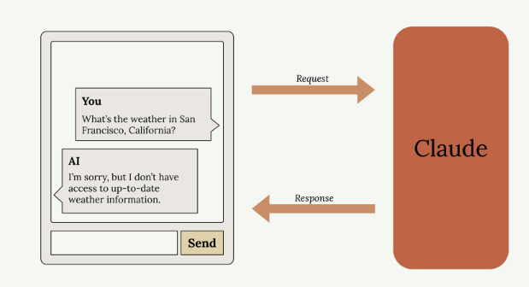
Without tools, Claude has no way to answer a question that needs current, real-world data.

How Tool Use Works
The pattern has four steps: you send Claude a question plus instructions for getting extra data; Claude asks for the specific data it needs; your server runs code to fetch it from an API or database; you send that data back so Claude can generate a complete final response.
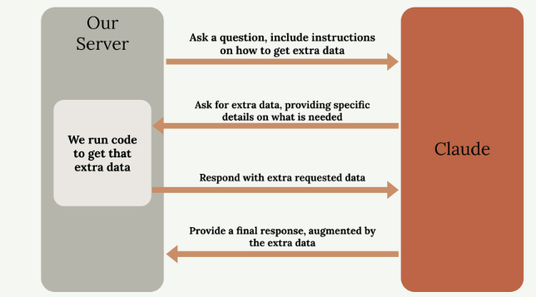
The four-step exchange between your server and Claude: ask, request extra data, respond with it, then get the final answer.

Weather Example in Practice
For the weather question, the same four steps become concrete: the prompt includes instructions on how to retrieve weather data, Claude asks the server to get current conditions for that location, the server calls a weather API and returns the data, and Claude combines it with the original question for an accurate, current answer.
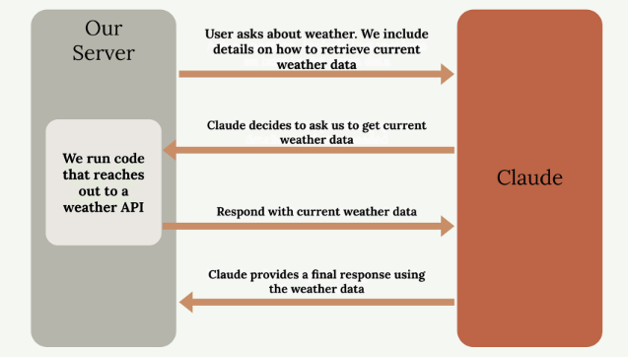
The generic flow applied to weather: the server calls a real weather API, then Claude answers using that data.

Key Benefits
Benefit | What it means
Real-time information | Access current data that wasn't available during training
External system integration | Connect Claude to databases, APIs, and other services
Dynamic responses | Answers reflect the latest available information
Structured interaction | Claude knows exactly what it needs and how to ask for it

Practice Questions — Lesson 1
Choose the single best answer for each question (A–E).
1. Why can't Claude answer a question about current weather by default?
A) Weather questions are blocked by the API
B) Claude only knows information from its training data, which has no real-time data
C) Weather requires a system prompt to be set
D) Claude can only answer questions about coding
E) The temperature parameter must be set to 0 first
2. What is the correct order of the tool use flow?
A) Tool Request → Initial Request → Final Response → Data Retrieval
B) Initial Request → Tool Request → Data Retrieval → Final Response
C) Data Retrieval → Initial Request → Tool Request → Final Response
D) Final Response → Data Retrieval → Tool Request → Initial Request
E) Initial Request → Data Retrieval → Tool Request → Final Response
3. In the tool use flow, who actually runs the code that fetches external data?
A) Claude, directly
B) The user's browser
C) Your server
D) The weather API itself, unprompted
E) A separate model dedicated to tool calls
4. In the weather example, what does Claude do after receiving the current weather data back from the server?
A) It ignores the data and answers from training knowledge
B) It asks for a second, unrelated piece of data
C) It generates a final response combining the original question with the fresh data
D) It stores the data for the next unrelated conversation
E) It ends the conversation without responding
5. Which of the following is listed as a key benefit of tool use?
A) Lower max_tokens usage
B) Guaranteed deterministic output at any temperature
C) External system integration — connecting Claude to databases, APIs, and other services
D) Removing the need for a system prompt
E) Automatically translating the user's question

Lesson 2 — Project Overview: Reminder Tool

Goal for Tool Use
We're going to build a practical project that teaches Claude how to set reminders for future dates. The goal: tell Claude "Set a reminder for my doctor's appointment. It's a week from Thursday" and have it respond "OK, I will remind you." This will require implementing 3-4 custom tools, and for now we'll focus on building just one.
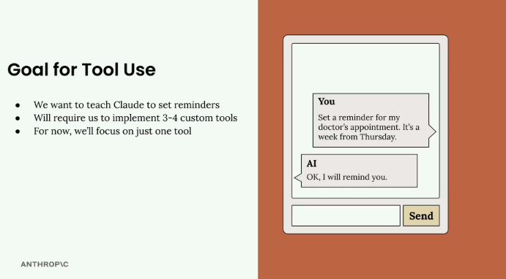
The target interaction: a natural-language reminder request, and Claude confirming it will remind you.

Why This Is Challenging
Claude knows the current date, but not always the exact time. It also doesn't always handle time-based addition well, especially many days into the future. And it has no built-in mechanism to actually set a reminder. Tools are how we bridge each of these gaps.

Tools We Need
We'll create three separate tools, one per problem: get the current date time (so Claude knows the precise date and time), add duration to date time (a reliable way to calculate future dates), and set a reminder (to actually record it in the system). We'll build these one at a time, starting with the simplest, to understand tool calling before adding complexity.
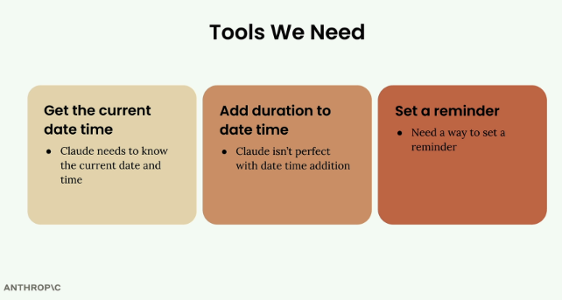
The three custom tools this project will implement, one per limitation.

Practice Questions — Lesson 2
Choose the single best answer for each question (A–E).
1. What is the target interaction this project aims to support?
A) Claude answering trivia questions about dates
B) A natural-language reminder request that Claude confirms it will handle
C) Claude translating dates between time zones
D) Claude generating a calendar UI
E) Claude summarizing a list of appointments
2. Which of the following is NOT listed as a reason this project is challenging for Claude?
A) Claude might not know the exact current time
B) Claude doesn't always handle time-based addition well
C) Claude has no built-in mechanism to set a reminder
D) Claude cannot understand natural language date references
E) None of the above — all are listed reasons
3. How many custom tools will this project implement in total?
A) One
B) Two
C) Three
D) Five
E) It's left open-ended
4. What is the purpose of the "add duration to date time" tool?
A) To translate the reminder into another language
B) To reliably calculate a future date/time, since Claude isn't perfect at this addition
C) To store the reminder permanently
D) To fetch the current weather for context
E) To validate the user's input format
5. What approach does the lesson recommend for building the three tools?
A) Build all three simultaneously to save time
B) Build them in a random order
C) Build them one at a time, starting with the simplest
D) Only build the most complex one first
E) Skip tool-by-tool testing and test everything at the end

Lesson 3 — Tool Function

What Are Tool Functions?
A tool function is a plain Python function that gets executed automatically when Claude decides it needs extra information to help a user. For example, if someone asks "What time is it?", Claude would call your date/time tool to get the current time.
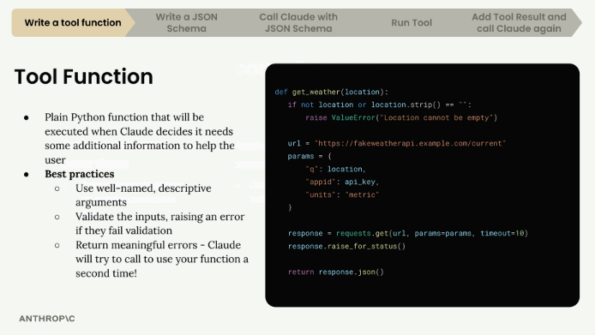
The five-step tool use pipeline (write a tool function → JSON schema → call Claude → run tool → add result and call again), and an example weather tool function with input validation.

Best Practices for Tool Functions
- Use descriptive names — both the function name and parameter names should clearly indicate their purpose.
- Validate inputs — check that required parameters aren't empty or invalid, and raise errors when they are.
- Provide meaningful error messages — Claude can see error messages and might retry the function call with corrected parameters.
Validation matters because Claude learns from errors: a clear message like "Location cannot be empty" can prompt Claude to retry with a proper value.

Building Your First Tool Function
A function to get the current date and time, accepting a format parameter so Claude can request the time in different formats:
def get_current_datetime(date_format="%Y-%m-%d %H:%M:%S"):
if not date_format:
raise ValueError("date_format cannot be empty")
return datetime.now().strftime(date_format)
It uses Python's datetime module to get the current time and format it according to the provided format string. The default format gives year-month-day hour:minute:second. Example usage:
# Default format: "2024-01-15 14:30:25"
get_current_datetime()

# Just hour and minute: "14:30"
get_current_datetime("%H:%M")
The validation check ensures Claude can't pass an empty string for the date format. This specific error is unlikely, but it demonstrates the pattern of validating inputs and providing helpful error messages Claude can learn from.

Next Steps
Creating the function is just the first step. Next comes writing a JSON schema that describes the function to Claude, then integrating it into the chat system. This approach gives Claude powerful capabilities while keeping the code organized and maintainable.

Practice Questions — Lesson 3
Choose the single best answer for each question (A–E).
1. What is a tool function?
A) A function that runs automatically on a schedule
B) A plain Python function that gets executed when Claude decides it needs extra information
C) A built-in Claude API endpoint
D) A function that only formats JSON
E) A function that replaces the system prompt
2. Why is input validation considered a best practice for tool functions?
A) It makes the function run faster
B) Claude can see error messages and may retry with corrected parameters
C) It is required by the Claude API to register a tool
D) It prevents the function from being called more than once
E) It removes the need for a JSON schema
3. In get_current_datetime(date_format="%Y-%m-%d %H:%M:%S"), what does the date_format parameter control?
A) The time zone used
B) Whether the function raises an error
C) The format of the returned date/time string
D) The number of retries Claude can attempt
E) Whether the function returns a string or an integer
4. What happens if get_current_datetime is called with an empty string as date_format?
A) It silently returns None
B) It raises a ValueError
C) It uses the default format automatically
D) It returns the current date with no time
E) It crashes the entire application
5. According to the lesson, what comes right after writing the tool function?
A) Deploying the application to production
B) Writing a JSON schema that describes the function to Claude
C) Deleting the function and starting over
D) Training a new model
E) Writing unit tests only, with no further integration

Lesson 4 — Tool Schemas

Understanding JSON Schema
After writing a tool function, the next step is a JSON schema that tells Claude what arguments the function expects and how to use it — it acts as documentation Claude reads to decide when and how to call the tool. JSON Schema isn't AI-specific; it's a widely-used data validation spec the AI community adopted because it conveniently describes function parameters.
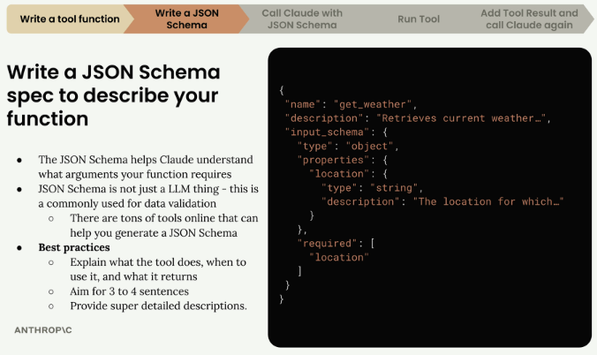
The tool spec has three parts: name, description, and input_schema — the actual schema describing the function's arguments.
The complete tool specification has three main parts: name (a clear, descriptive tool name, like "get_weather"), description (what the tool does, when to use it, and what it returns), and input_schema (the JSON schema describing the function's arguments).
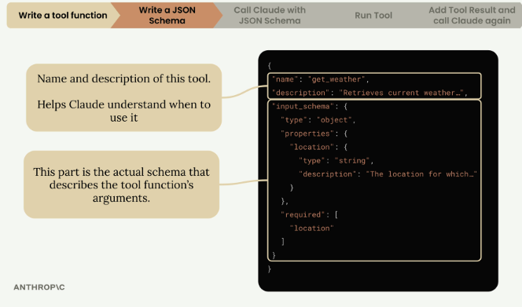
Name and description help Claude decide when to use the tool; input_schema is the actual spec describing the function's arguments.

Writing Effective Descriptions
- Aim for 3-4 sentences explaining what the tool does.
- Describe when Claude should use it.
- Explain what data it returns.
- Provide detailed descriptions for each argument.

The Easy Way to Generate Schemas
Instead of writing JSON schemas from scratch, you can ask Claude to generate them: copy the tool function code, ask Claude to write a JSON schema for tool calling, include the Anthropic documentation on tool use as context, and let it generate a properly formatted schema following best practices. A good prompt: "Write a valid JSON schema spec for the purposes of tool calling for this function. Follow the best practices listed in the attached documentation."

Implementing the Schema in Code
Once generated, copy the schema into the code file, using the naming pattern function_name followed by function_name_schema to keep schemas organized and easy to match with their functions:
def get_current_datetime(date_format="%Y-%m-%d %H:%M:%S"):
if not date_format:
raise ValueError("date_format cannot be empty")
return datetime.now().strftime(date_format)

get_current_datetime_schema = {
"name": "get_current_datetime",
"description": "Returns the current date and time formatted according to the specified format",
"input_schema": {
"type": "object",
"properties": {
"date_format": {
"type": "string",
"description": "A string specifying the format of the returned datetime. Uses Python's strftime format codes.",
"default": "%Y-%m-%d %H:%M:%S"
}
},
"required": []
}
}

Adding Type Safety
For better type checking, import and use the ToolParam type from the Anthropic library. This isn't strictly necessary for functionality, but it prevents type errors when the schema is used with Claude's API and makes the code more robust:
from anthropic.types import ToolParam

get_current_datetime_schema = ToolParam({
"name": "get_current_datetime",
"description": "Returns the current date and time formatted according to the specified format",
# ... rest of schema
})

Practice Questions — Lesson 4
Choose the single best answer for each question (A–E).
1. What are the three main parts of a complete tool specification?
A) name, input_schema, and output_schema
B) name, description, and input_schema
C) function, arguments, and return_type
D) title, body, and footer
E) type, format, and default
2. Is JSON Schema specific to AI or tool calling?
A) Yes, it was invented for AI tool calling
B) No, it's a widely-used data validation spec the AI community adopted
C) Yes, but only for Anthropic's API
D) No, it only works with Python
E) Yes, it was created by Anthropic
3. According to the lesson, roughly how many sentences should a tool description be?
A) 1 sentence
B) 3-4 sentences
C) 10+ sentences
D) No limit is suggested
E) Exactly 2 words
4. What is the recommended "easy way" to generate a JSON schema for a tool function?
A) Write it manually with no reference material
B) Ask Claude to generate it, providing the function code and the tool-use documentation as context
C) Copy a random schema from the internet
D) Use a schema from an unrelated tool
E) Skip the schema and only rely on the docstring
5. What is the purpose of importing ToolParam from the Anthropic library?
A) It is required for the function to run at all
B) It adds type safety and prevents type errors when using the schema with Claude's API
C) It automatically generates the tool function's code
D) It replaces the need for a description field
E) It converts the schema into YAML format

Lesson 5 — Handling Message Blocks

Making Tool-Enabled API Calls
To let Claude use tools, include a tools parameter in the API call — a list of JSON schemas describing the available functions Claude can call:
messages = []
messages.append({
"role": "user",
"content": "What is the exact time, formatted as HH:MM:SS?"
})

response = client.messages.create(
model=model,
max_tokens=1000,
messages=messages,
tools=[get_current_datetime_schema],
)

Understanding Multi-Block Messages
When Claude decides to use a tool, it returns an assistant message with multiple blocks in the content list — a significant change from the simple text-only responses seen before. A multi-block message typically contains a Text Block (human-readable text explaining what Claude is doing) and a ToolUse Block (instructions for your code about which tool to call and what parameters to use).
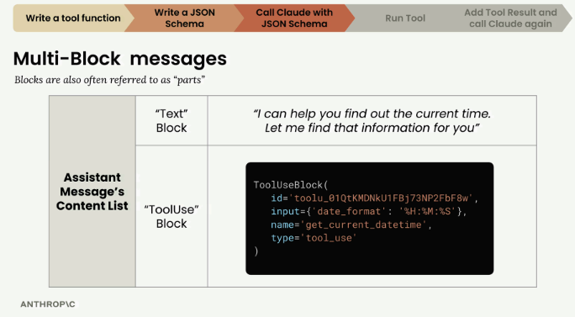
An assistant message's content list can hold a "Text" block and a "ToolUse" block — blocks are also called "parts".
The ToolUse block includes an ID for tracking the tool call, the name of the function to call (like "get_current_datetime"), input parameters formatted as a dictionary, and the type designation "tool_use".

Managing Conversation History with Multi-Block Messages
Claude doesn't store conversation history, so you manage it manually. When working with tool responses, you must preserve the entire content structure, including all blocks:
messages.append({
"role": "assistant",
"content": response.content
})
This preserves both the text block and the tool use block, which is crucial for maintaining conversation context in subsequent API calls.

The Complete Tool Usage Flow
- Send the user message with the tool schema to Claude.
- Receive an assistant message with a text block and a tool use block.
- Extract the tool information and execute the actual function.
- Send the tool result back to Claude along with the complete conversation history.
- Receive the final response from Claude.

Updating Helper Functions
Helper functions like add_user_message() and add_assistant_message() usually only support single text blocks, so they need updating to accommodate the more complex content structures that include tool use blocks — essential for building robust applications that integrate Claude's tool capabilities while maintaining proper conversation flow.

Practice Questions — Lesson 5
Choose the single best answer for each question (A–E).
1. What parameter must be included in the API call to let Claude use tools?
A) functions
B) tools
C) schema
D) actions
E) callables
2. What does a multi-block assistant message typically contain when Claude decides to use a tool?
A) Only a ToolUse block
B) A Text block and a ToolUse block
C) Only an error block
D) A single plain string
E) A list of previous user messages
3. Which of the following is NOT part of a ToolUse block?
A) An ID for tracking the tool call
B) The name of the function to call
C) Input parameters formatted as a dictionary
D) The type designation "tool_use"
E) The full conversation history
4. Why must the entire response.content be preserved when appending the assistant message to history?
A) It's optional and only improves formatting
B) It preserves both the text and tool use blocks, which Claude needs for context in later calls
C) It reduces the number of tokens used
D) It automatically triggers the tool to run
E) It replaces the need for the tools parameter in future calls
5. Why do helper functions like add_assistant_message() typically need to be updated for tool use?
A) Because tool calls require a different model
B) Because they usually only support single text blocks, not multi-block content
C) Because Claude no longer needs conversation history with tools
D) Because tool use disables all previous messages
E) Because the API key format changes when tools are used

Lesson 6 — Sending Tool Results

Running the Tool Function
When Claude responds with a tool use block, you extract the input parameters and call your function. The block's input is a dictionary of the arguments Claude wants to pass:
response.content[1].input
Since the function expects keyword arguments rather than a dictionary, use Python's unpacking syntax:
get_current_datetime(**response.content[1].input)

Tool Result Block
After running the tool function, send the results back to Claude using a tool result block, placed inside a user message. It communicates the results of running a tool function back to Claude.
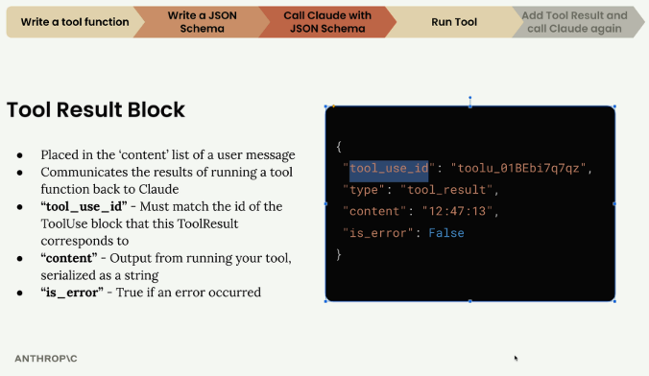
A tool_result block: tool_use_id matches the originating ToolUse block, content is the tool's output as a string, is_error flags whether an error occurred.
- tool_use_id — must match the id of the ToolUse block this ToolResult corresponds to.
- content — output from running the tool, serialized as a string.
- is_error — True if an error occurred.

Handling Multiple Tool Calls
Claude can request multiple tool calls in a single response — for example, asked "What's 10 + 10 and what's 30 + 30?", it might return two separate ToolUse blocks. Each tool call gets a unique ID, and results must be matched to those IDs so Claude knows which result corresponds to which request, even if they arrive in a different order.
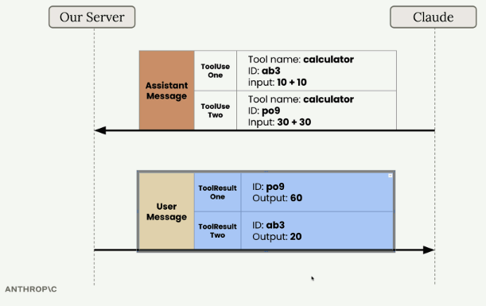
Two ToolUse blocks (ab3, po9) in one assistant message, matched to two ToolResult blocks by ID in the follow-up user message.

Building the Follow-up Request
The follow-up request must include the complete conversation history plus the new tool result:
messages.append({
"role": "user",
"content": [{
"type": "tool_result",
"tool_use_id": response.content[1].id,
"content": "15:04:22",
"is_error": False
}]
})
The complete message history now contains: the original user message, the assistant message with the tool use block, and the user message with the tool result block.

Making the Final Request
The follow-up request must still include the tool schema, even though Claude isn't expected to make another tool call — it needs the schema to understand the tool references already in the conversation history:
client.messages.create(
model=model,
max_tokens=1000,
messages=messages,
tools=[get_current_datetime_schema]
)
Claude then responds with a final message that incorporates the tool results into a natural reply for the user, completing the tool use workflow end to end.
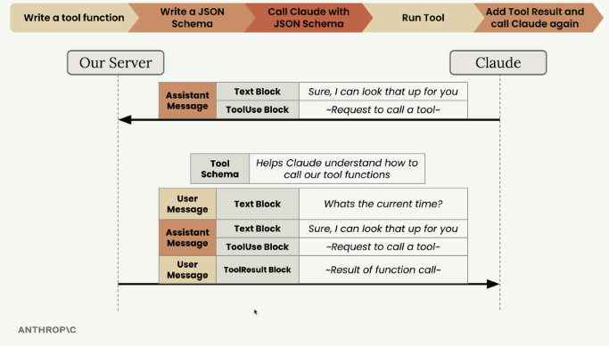
The full round trip: user message → assistant text + tool use → tool result → Claude's final natural-language response, with the tool schema present throughout.

Practice Questions — Lesson 6
Choose the single best answer for each question (A–E).
1. How do you call a tool function using the input from a ToolUse block?
A) get_current_datetime(response.content[1].input)
B) get_current_datetime(**response.content[1].input)
C) get_current_datetime.run(response)
D) response.content[1].call()
E) get_current_datetime(response)
2. Which field of a tool_result block must match the id of the originating ToolUse block?
A) content
B) is_error
C) tool_use_id
D) type
E) name
3. If Claude requests two tool calls in one response, how does your code know which result belongs to which request?
A) By the order the results are sent, always
B) By matching each tool_use_id to the corresponding ToolUse block's id
C) It doesn't matter, Claude re-matches them automatically
D) By the tool's name only
E) By timestamp
4. What role does the message containing a tool_result block have?
A) assistant
B) system
C) user
D) tool
E) function
5. Why must the tools parameter still be included in the final follow-up request, even though Claude isn't expected to call a tool again?
A) It isn't required — this is a common mistake
B) Claude needs the schema to understand the tool references already in the conversation history
C) It forces Claude to always call the tool one more time
D) It reduces the token count of the request
E) It replaces the need for the tool_result block

